|  |  |
| --- | --- |
| **Name:- Aryan Dilipbhai Langhanoja** | **Roll Number:- 92200133030** |
| **Subject Name and Code:-** Foundation Skills On Sensor Interfacing (01CT1103) | **Date of Experiment:- 11-11-2022** |

|  |  |
| --- | --- |
| Task:- |  |

Blinking an LED using the Arduino Board.

|  |  |
| --- | --- |
| Components: |  |

* Arduino Uno R3
* LED
* Jumper Wires (Male To Male)
* Bread Board
* Laptop Or PC

|  |  |
| --- | --- |
| About the Project:- |  |

* In thisproject, we are going to use Arduino to blink the LED.This is our first project with Arduino.

|  |  |
| --- | --- |
| Schematic:- |  |

* In this Project, We will connect One Resistor With Digital Pin 3 Of Arduino And Connect Other Terminal Of Resistor With Anode Of LED. And Cathode Is Connected With Ground. After That We Will Program the Arduino In Such A Way That At Pin 3 Per Second, There Is A HIGH Voltage Of 5V and LOW Voltage Of 0V.

|  |  |  |
| --- | --- | --- |
| Output:- (you circuit implementation |  |  |

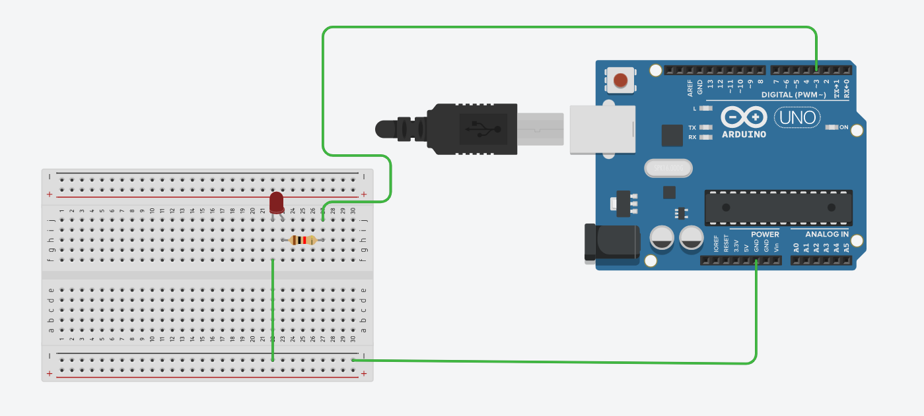

|  |  |
| --- | --- |
| Code:- |  |

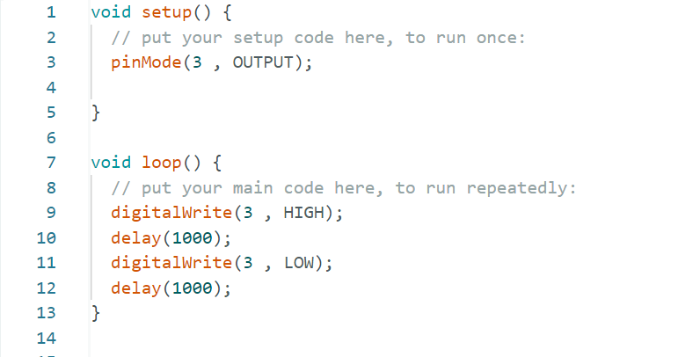

|  |  |
| --- | --- |
| Application:- |  |

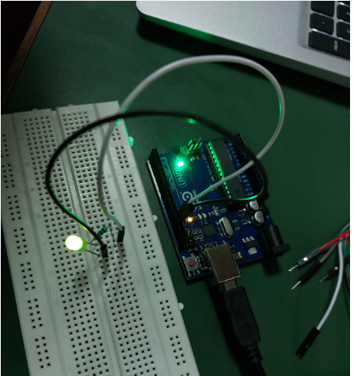

|  |  |
| --- | --- |
| Conclusion:- |  |

* In This Experiment, We Learnt That How To Blink LED With Arduino. How To Make Connections etc.